AUTHOR PORTFOLIO

J. K. Rowling

British author

STEP1: Creating Navigation Pages using the Content Page.

AUTHOR PORTFOLIO BOOKS:

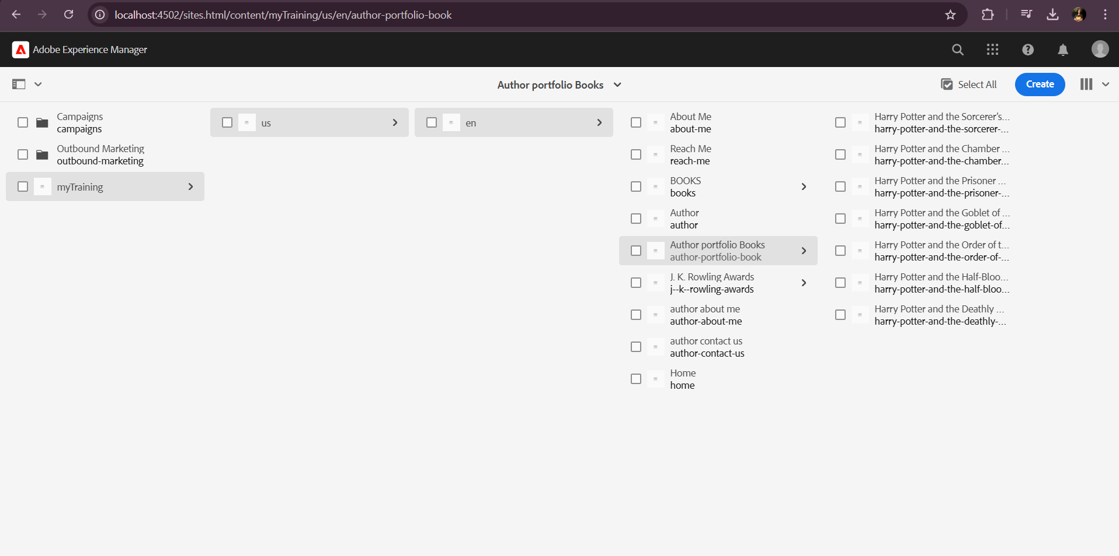

JK-ROWLING AWARDS:

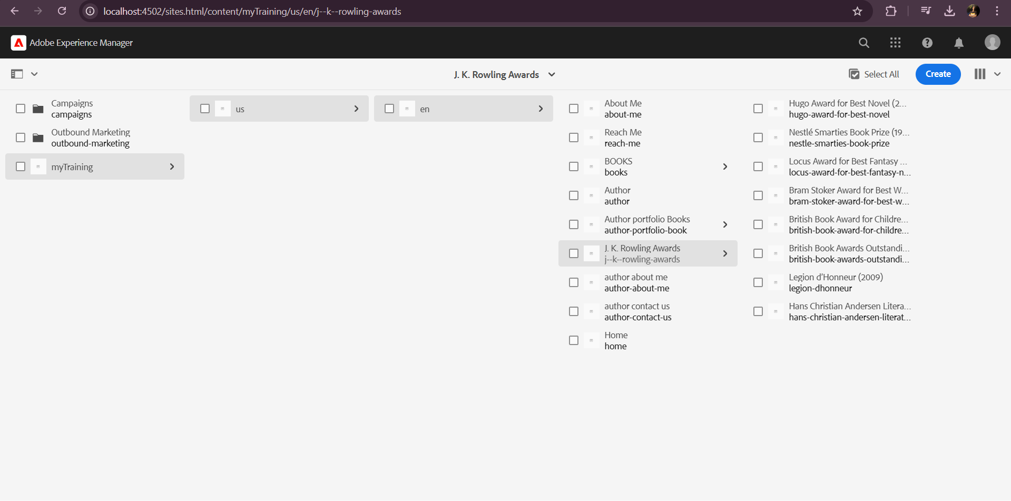

STEP2: Creating Template

AUTHOR PORTFOLIO TEMPLATE

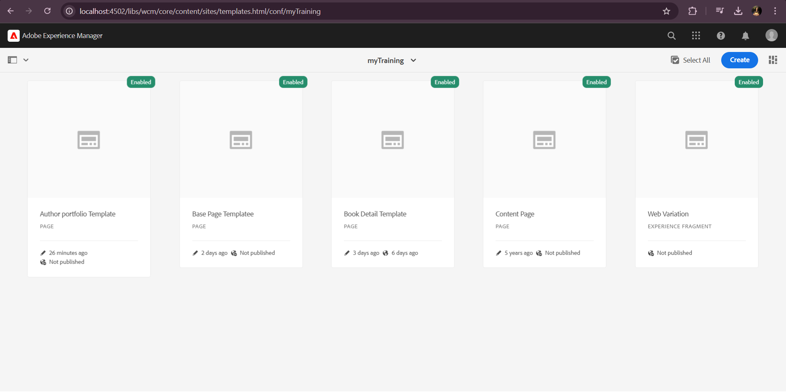

STEP3: Using the Template that we created , creating pages for the awards.



STEP4: Styling Header using Embed component.

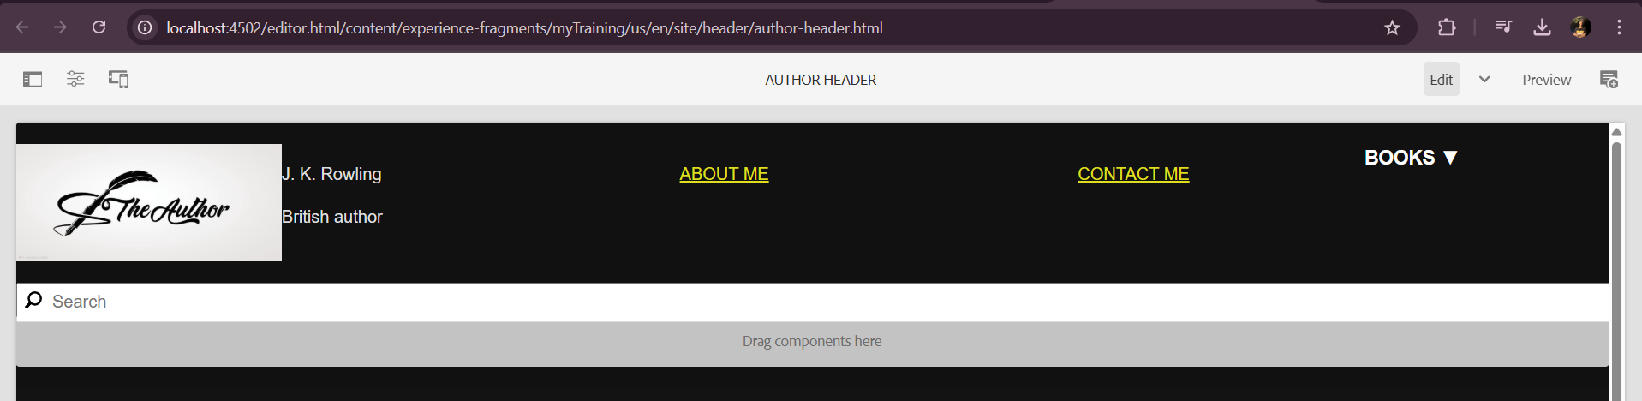

STEP4: Styling Footer using Embed component.

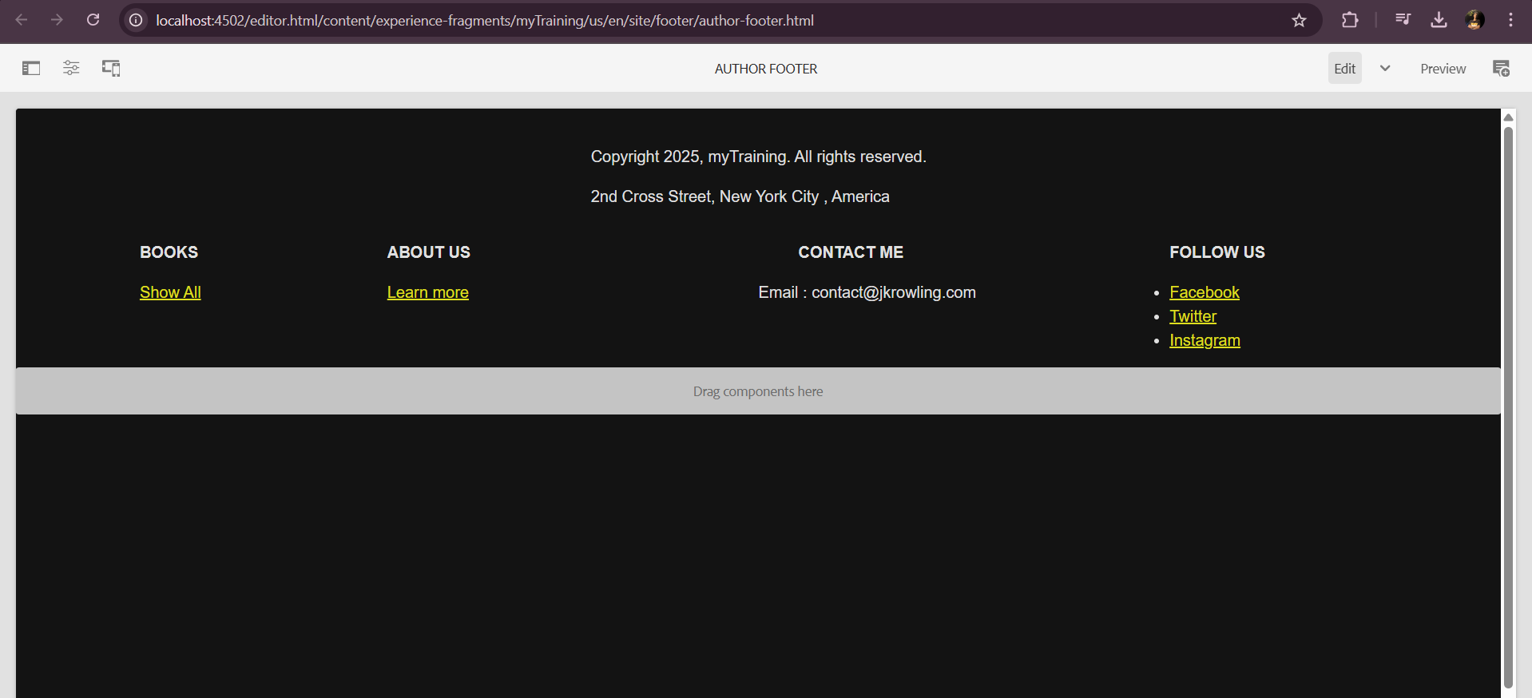

STEP5: Book Page Component

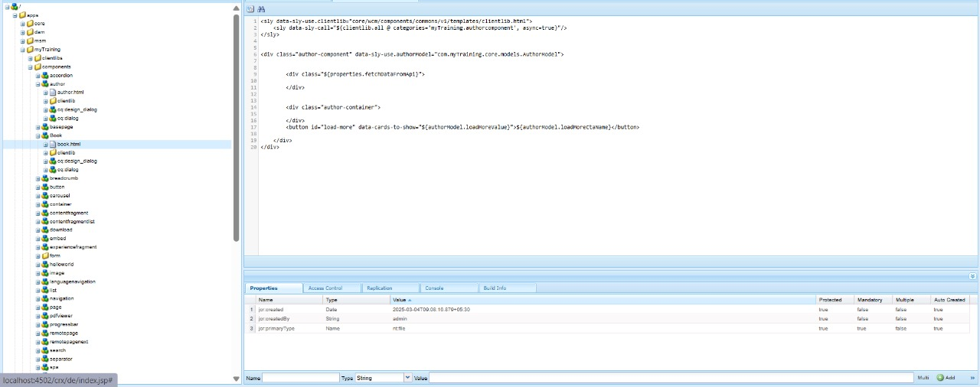

STEP5: BookModelImplementation(sling)

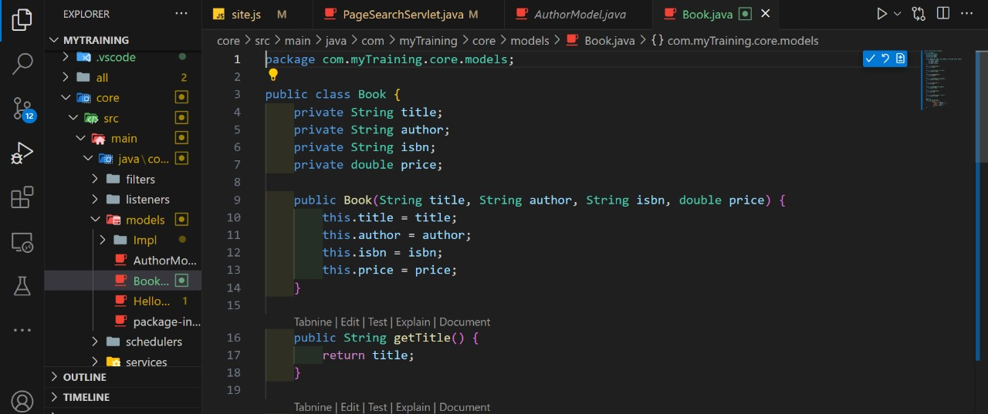

STEP 6: JSON file (Third party API) for books

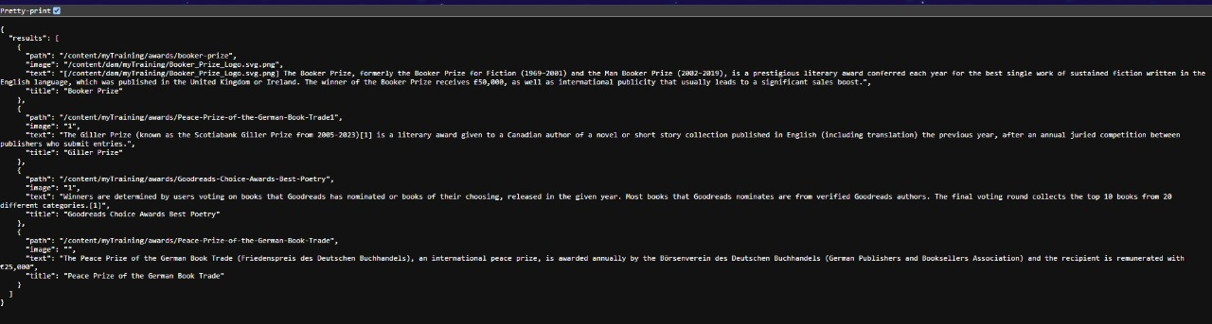

OUTPUT:

AUTHOR WEBSITE:

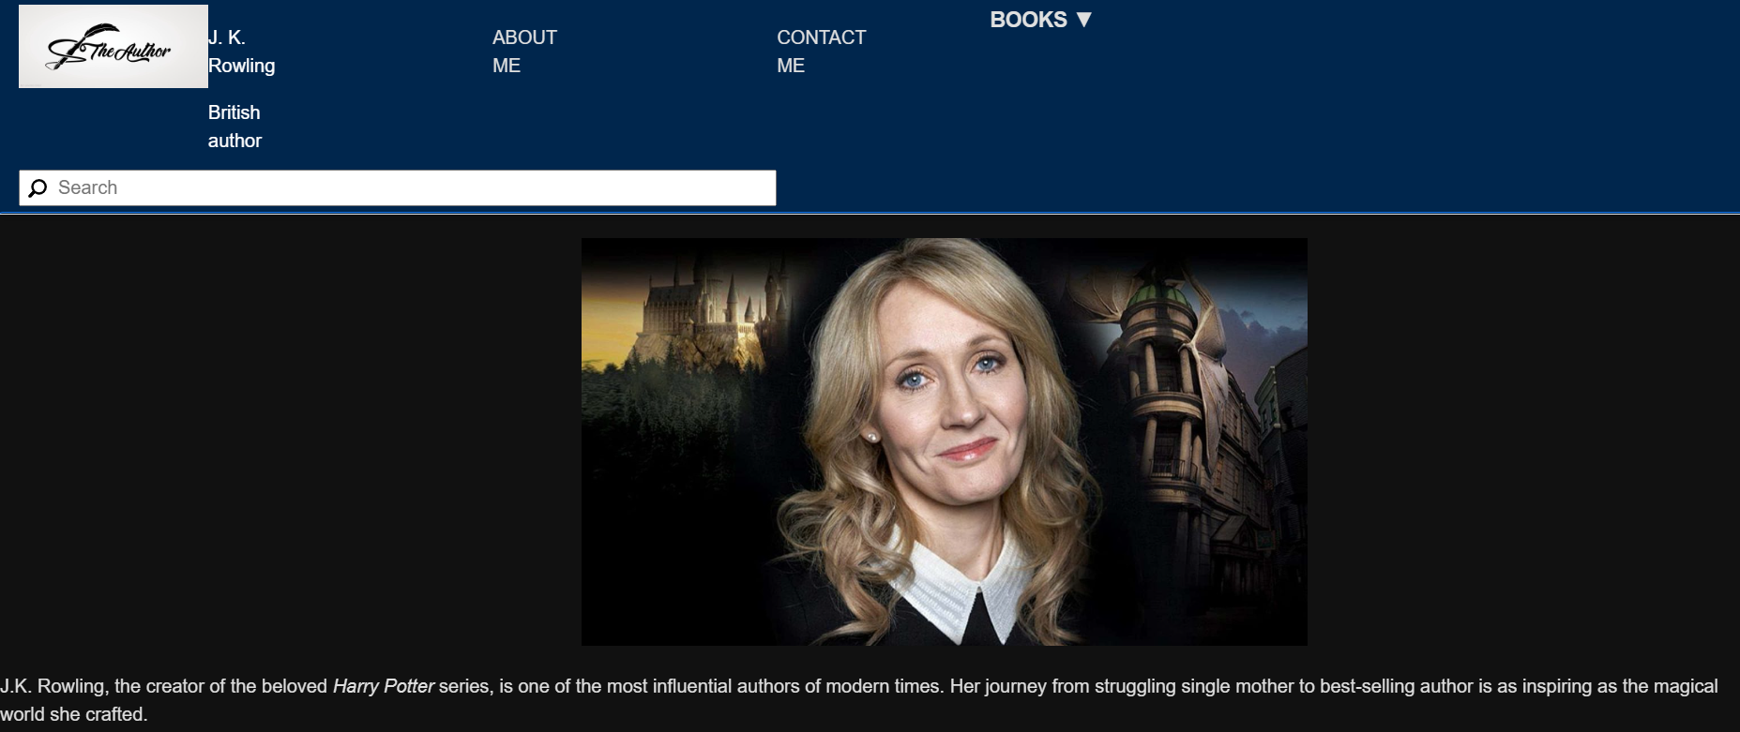

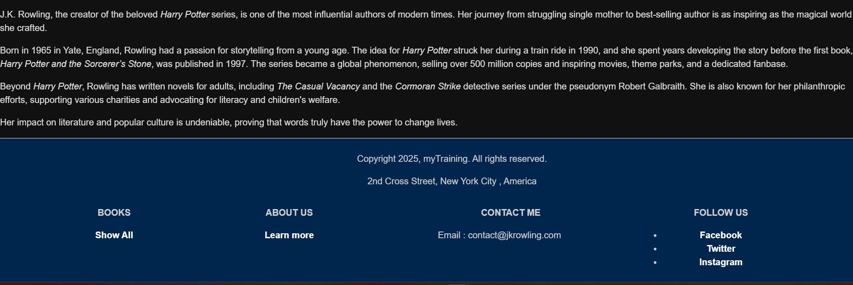

HOME PAGE:

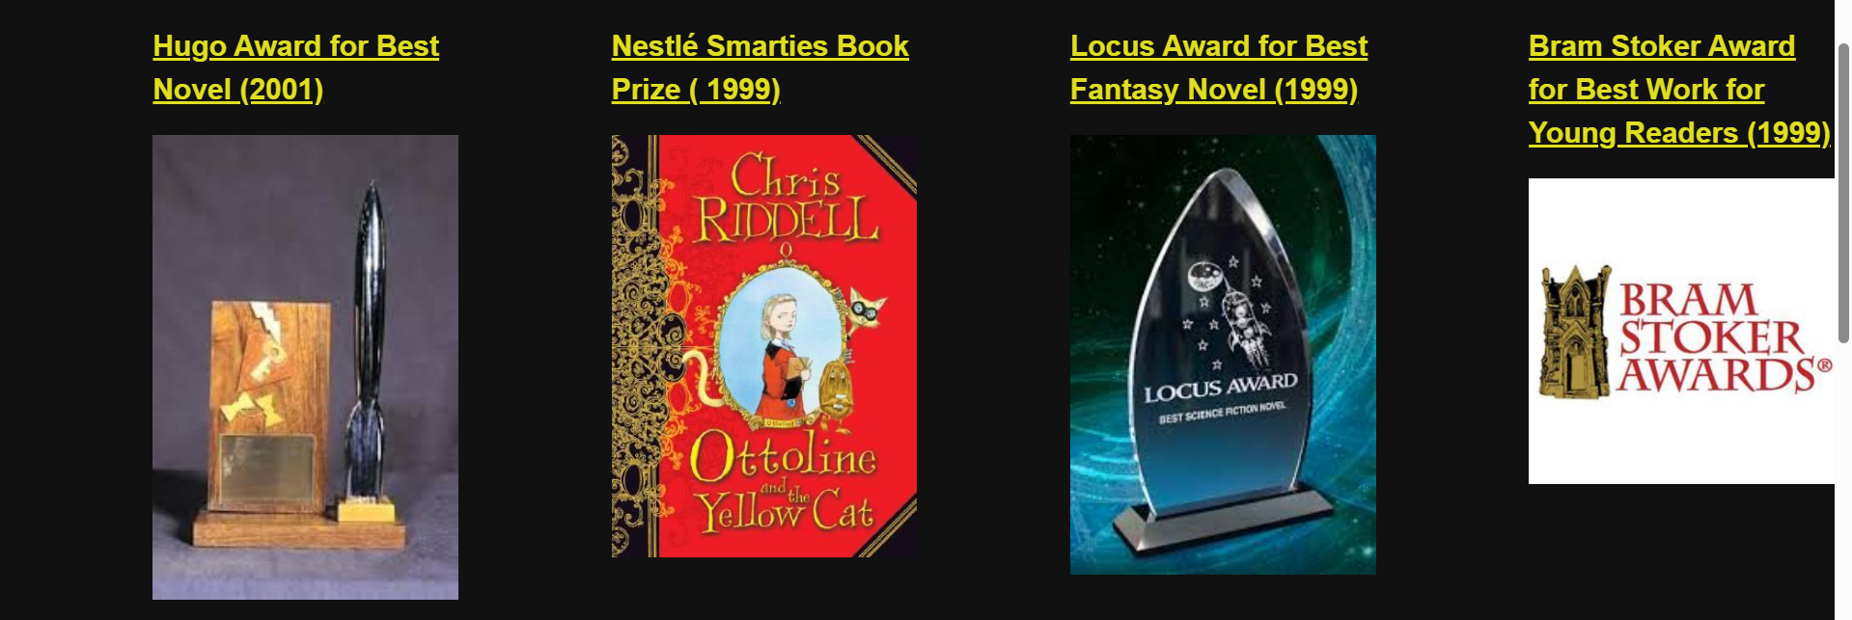

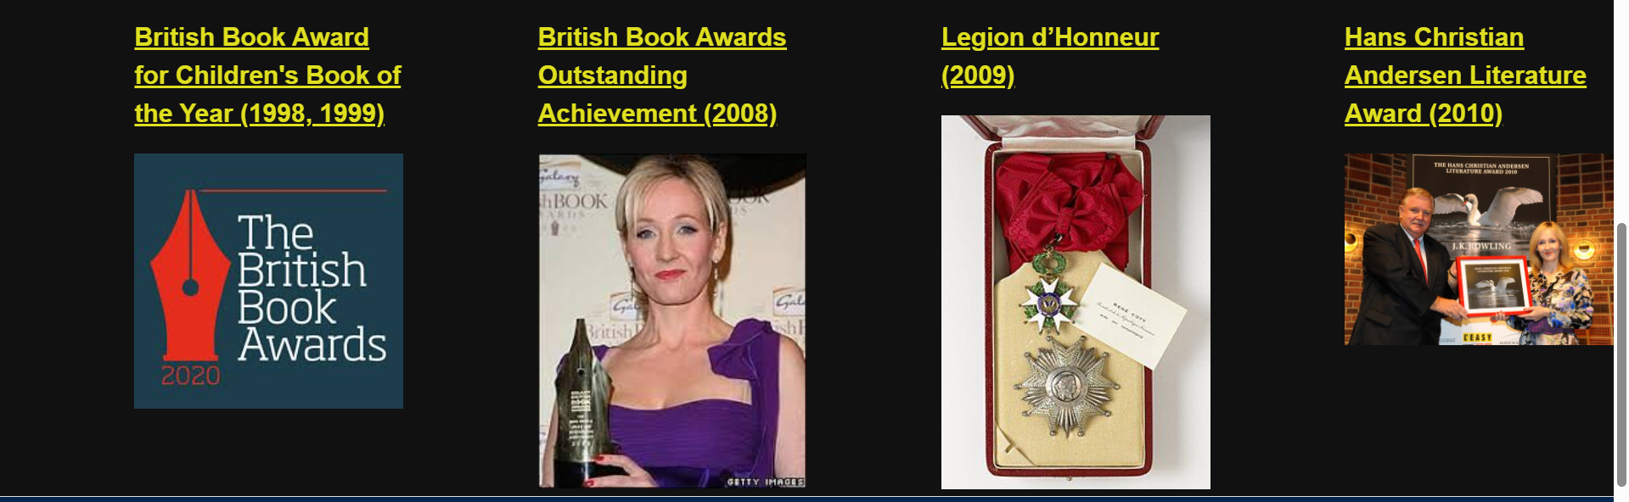



AWARD PAGE:

Hugo Award for Best Novel (2001)

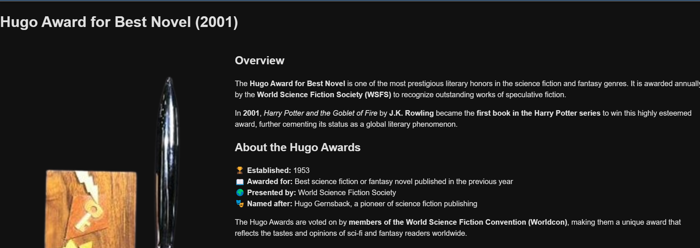

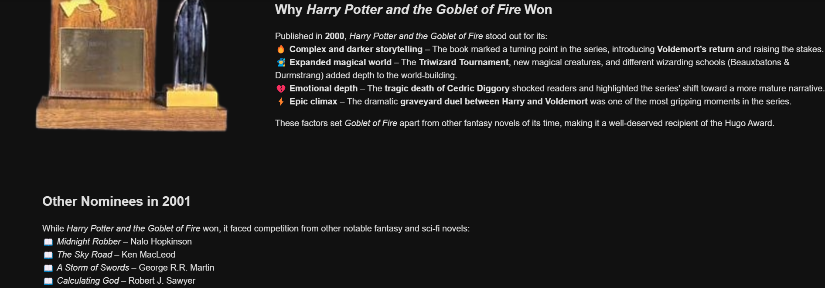

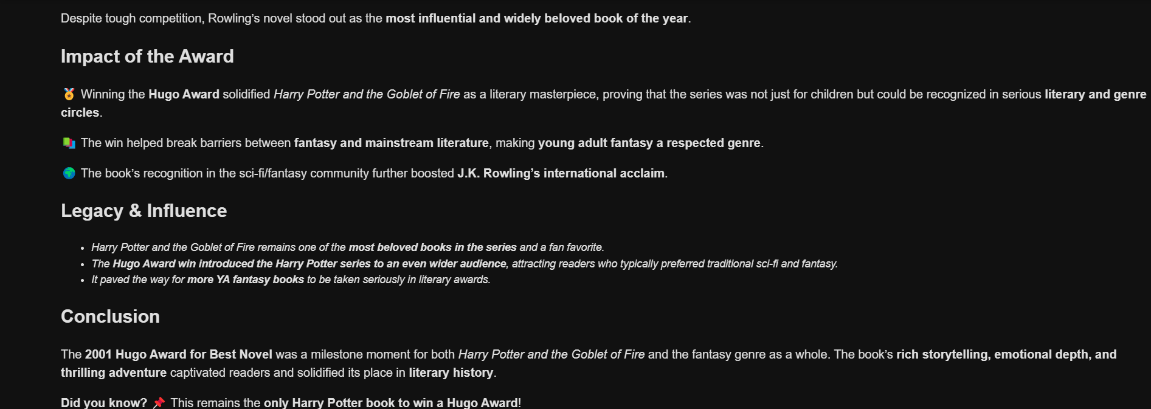



**Locus Award for Best Fantasy Novel (1999)**

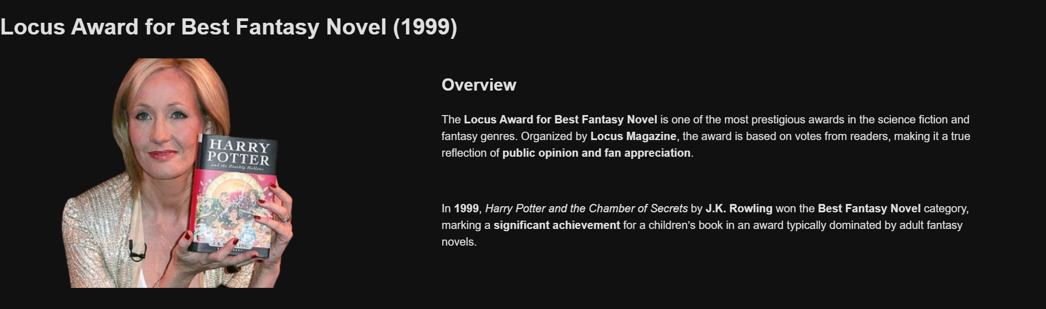

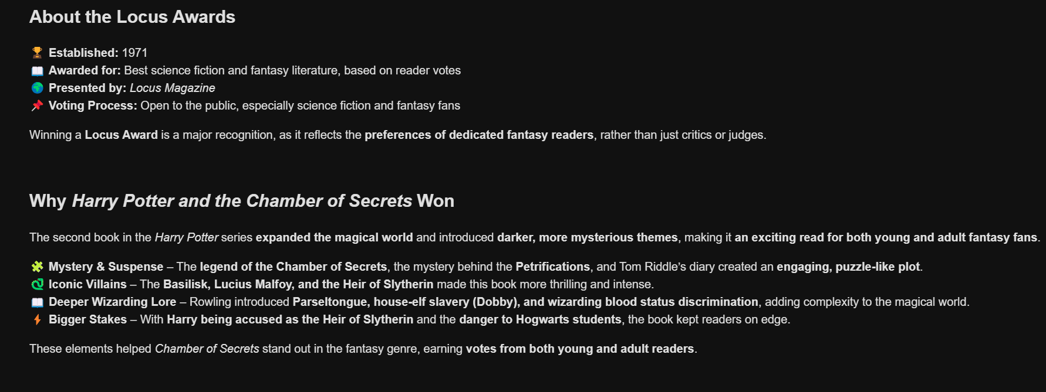

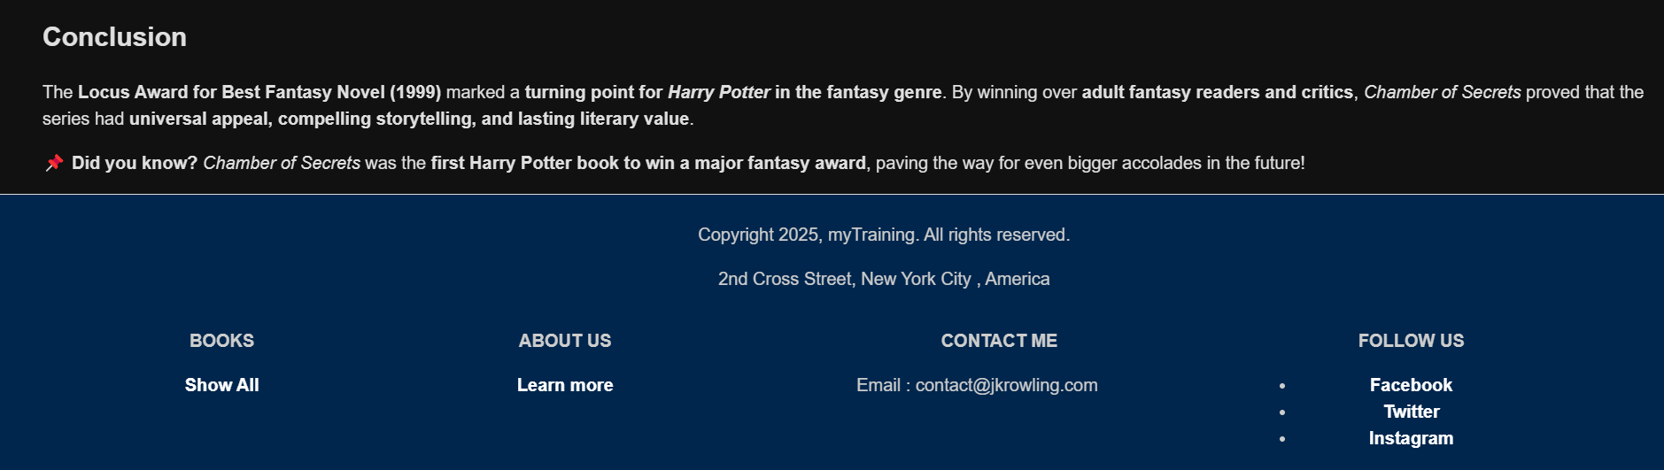

ABOUT ME:

With Author component

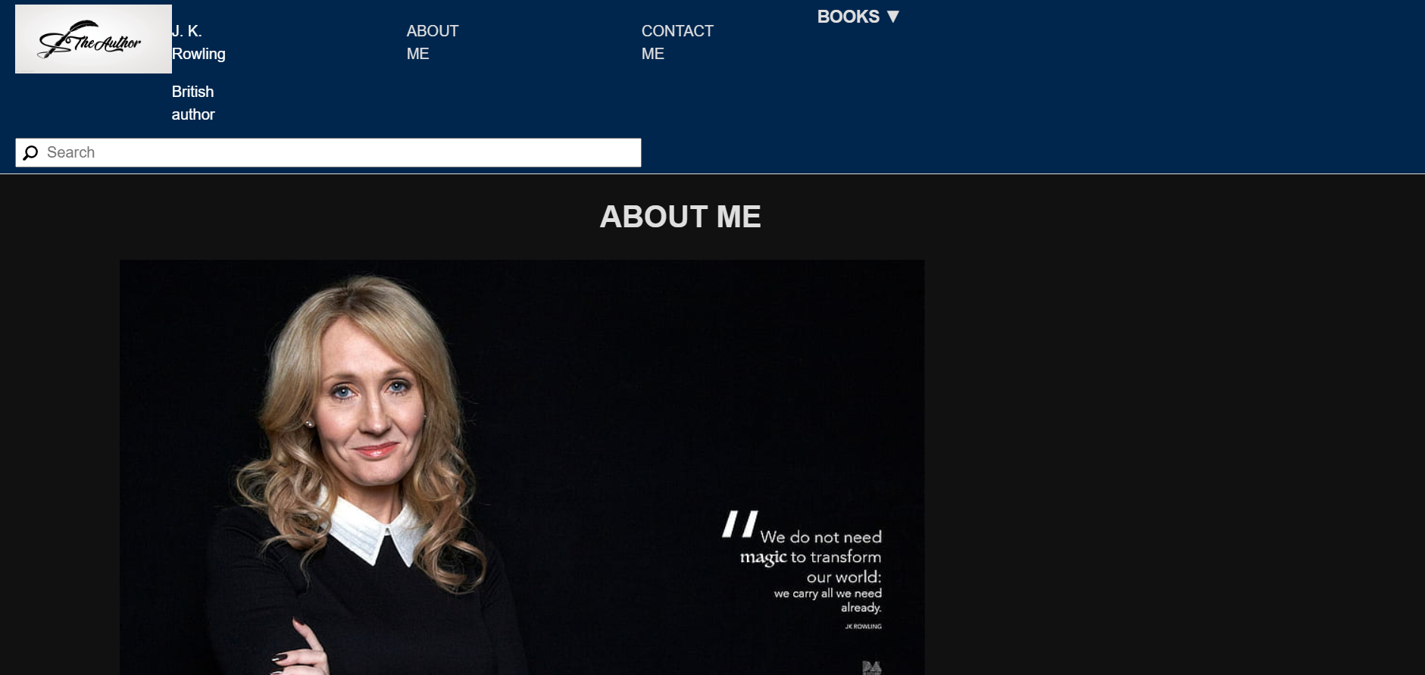

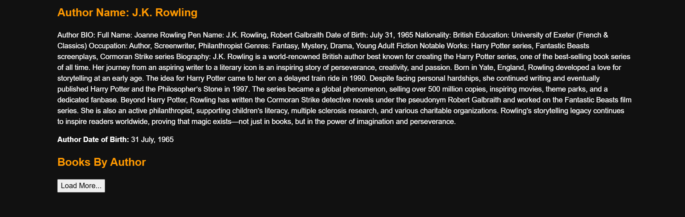



CONTACT ME:

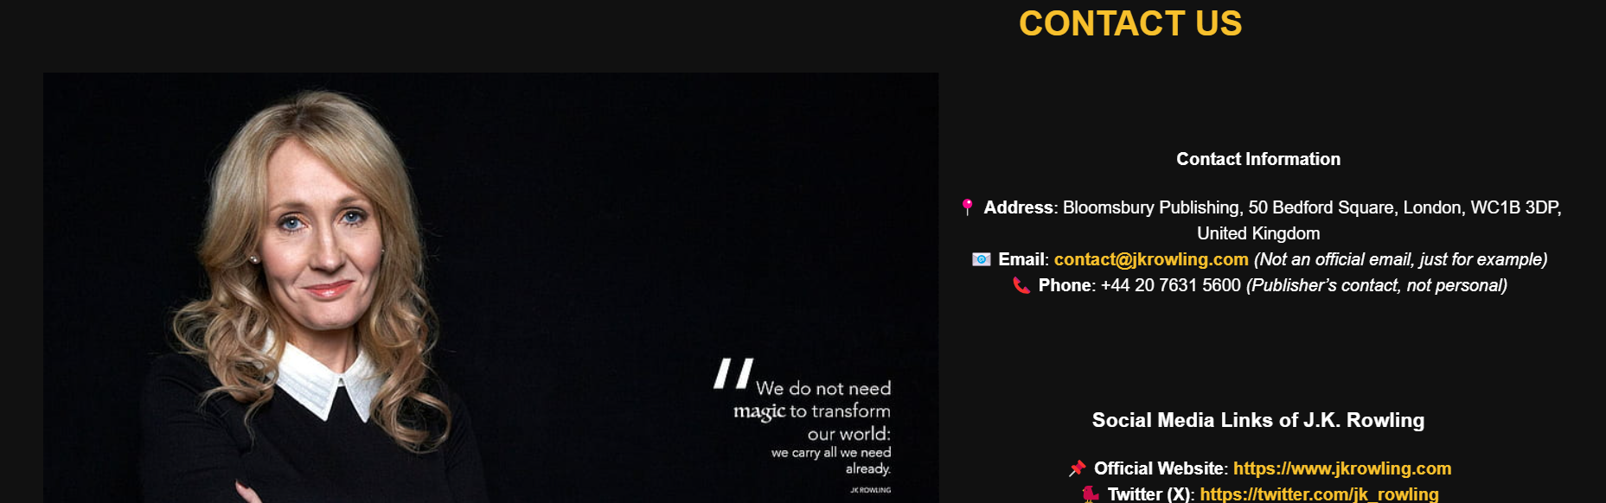

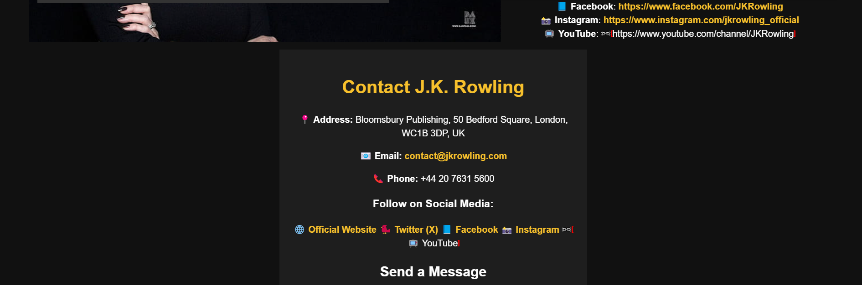



BOOKS PAGE:

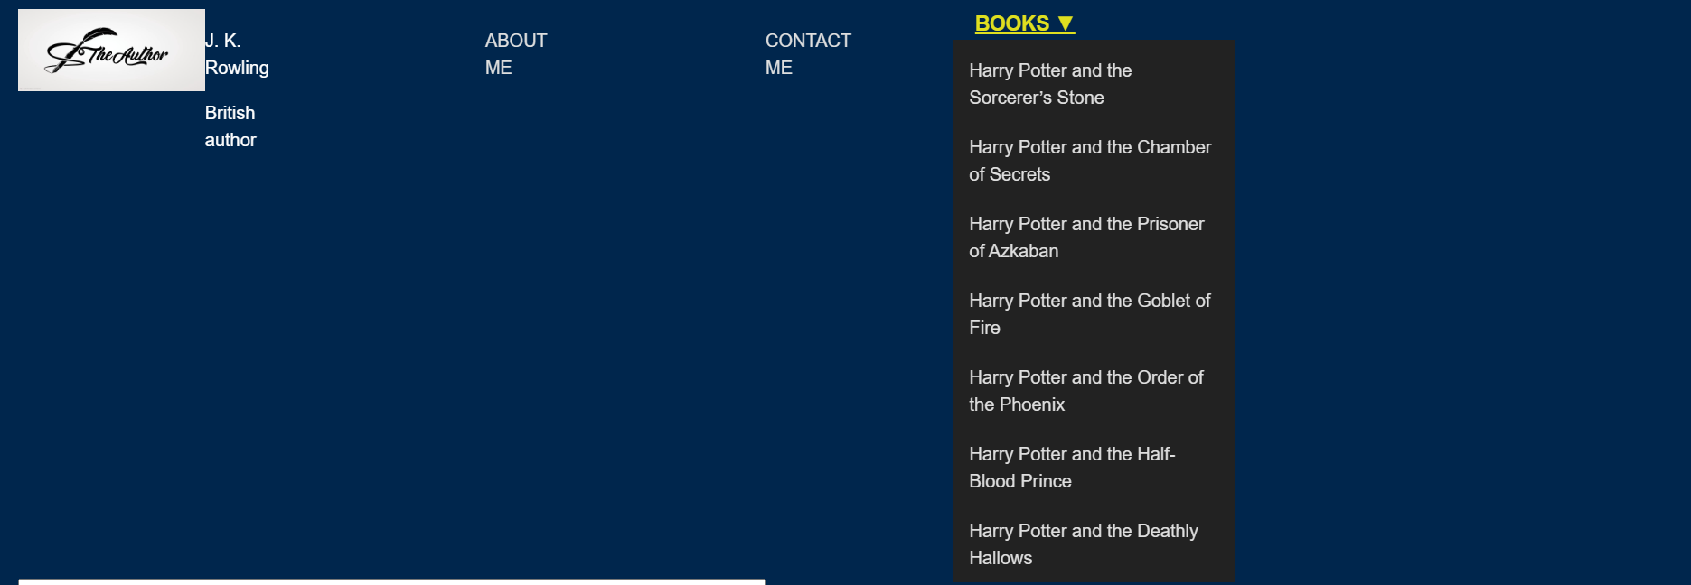

Drop Down Menu:

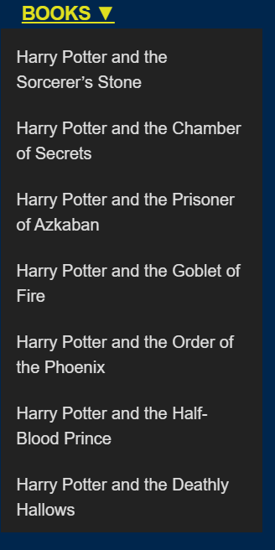

Book Page:

